**INTIALIZING SPRING FOR BOTH ACCOUNT AND LOAN APPLICATION**

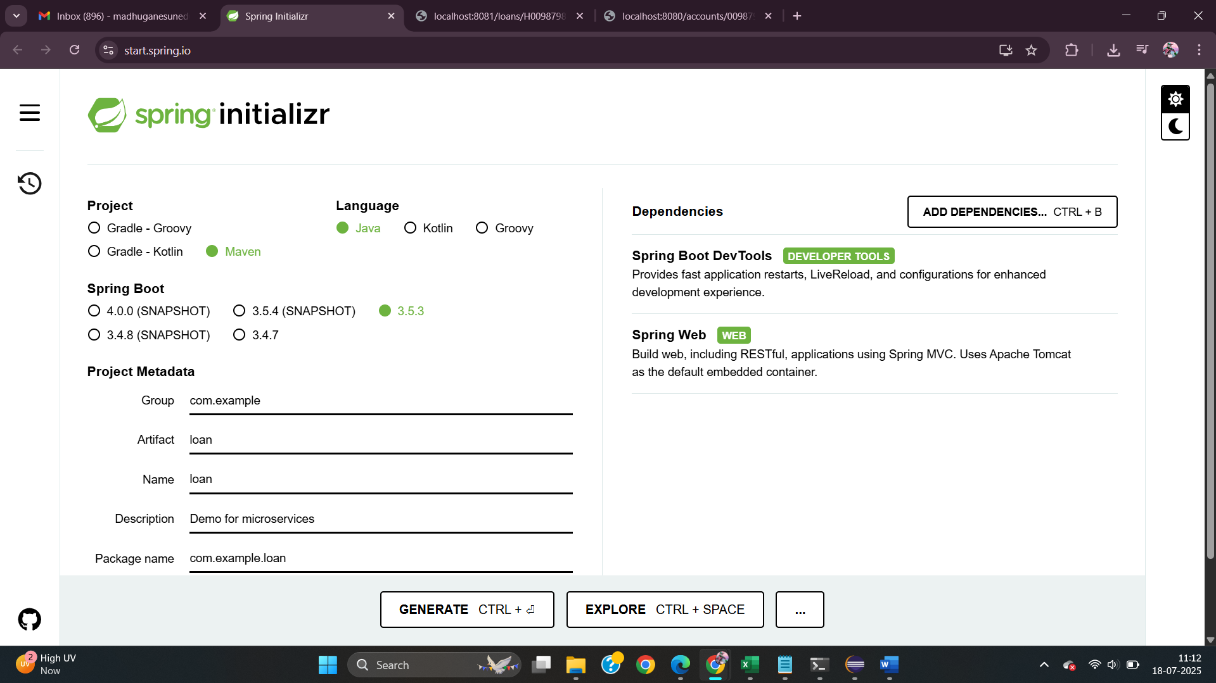

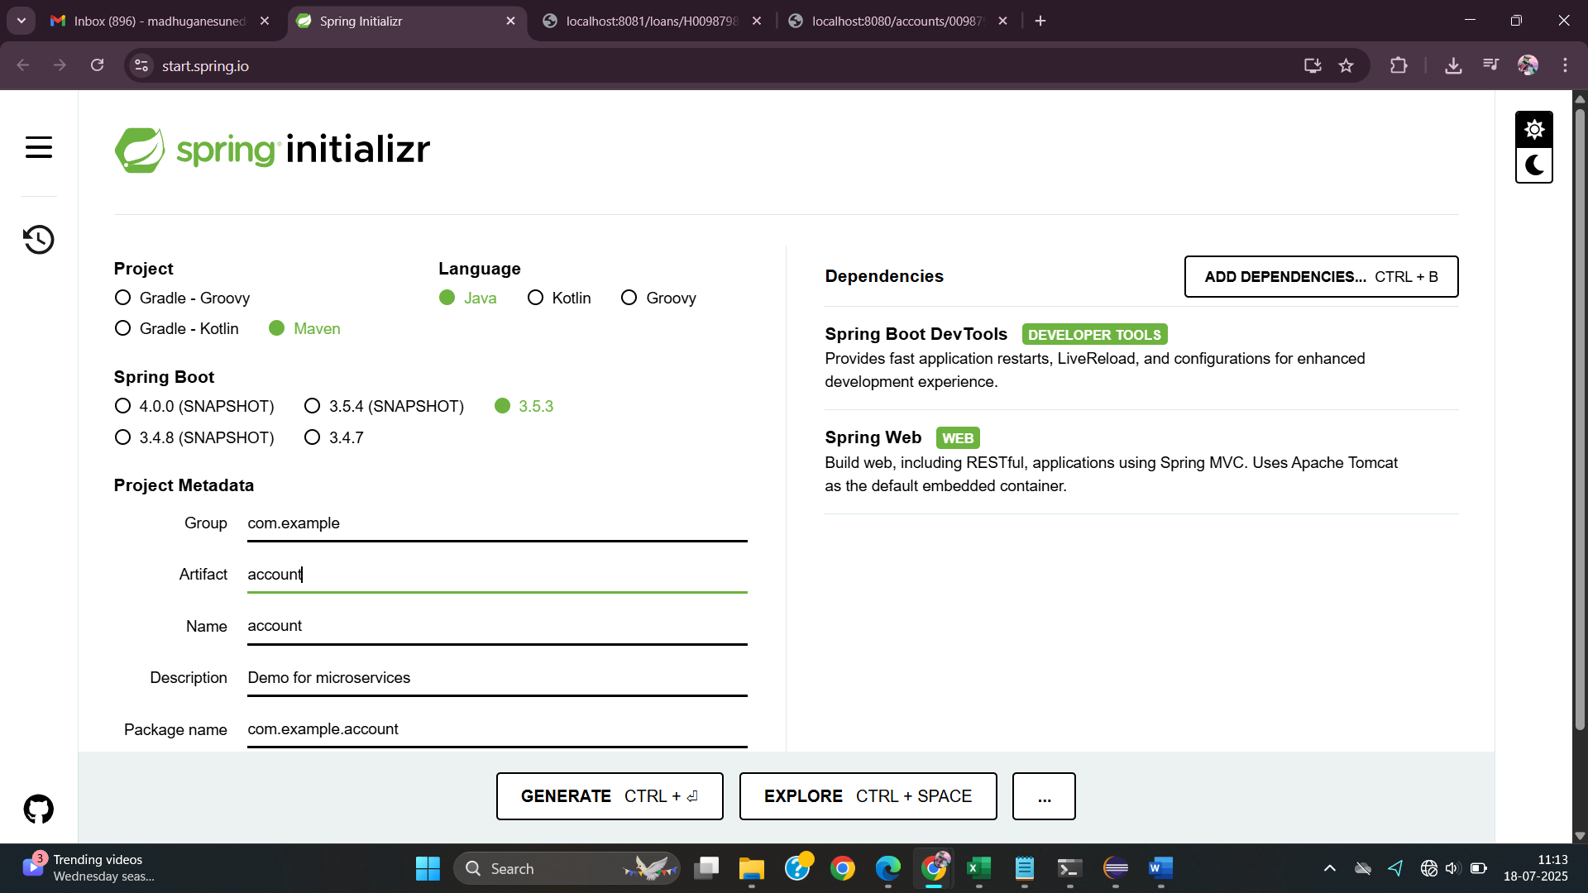

**FILE STRUCTURE FOR LOAN MICROSERVICE**

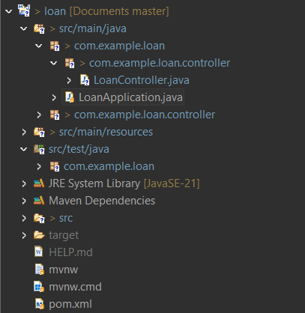

**FILE SRTUCTURE FOR ACCOUNT MICROSERVICE**

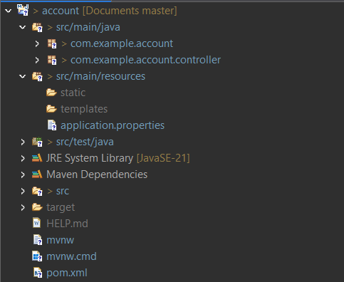

**ACCOUNT APPLICATION**

**AccountController.java**

**LOAN APPLICATION**

**LoanController.java**

**EXECUTION OF LOAN APPLICATION**

**EXECUTION OF ACCOUNT APPLICATION**

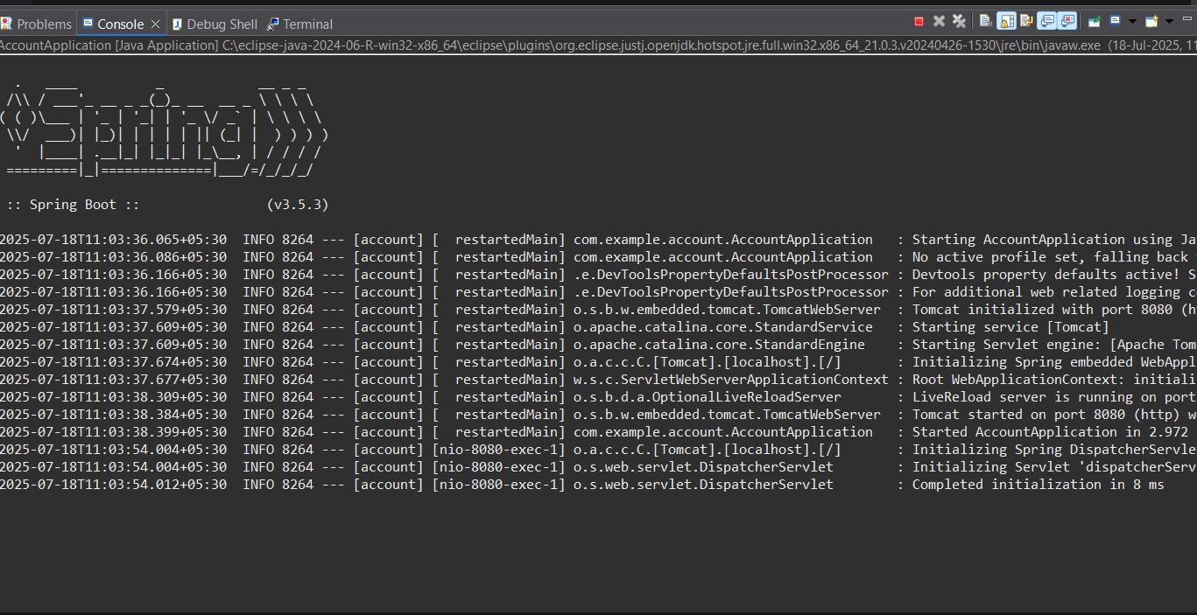

**OUTPUT ON CHROME:**

LOAN SERVICE

ACCOUNT SERVICE

**OUTPUT ON POSTMAN**

**LOAN SERVICE**

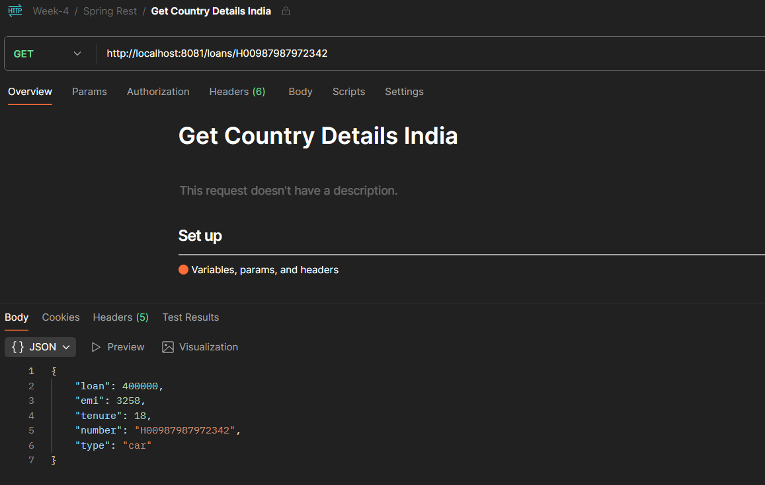

**ACCOUNT SERVICE**

Two microservices running on different ports

USING CONSOLE VIEW TAB IN ECLIPSE

